PYTHON CASE STUDY REPORT

NAME: VELIVENTI LASYAPRIYA
BRANCH: CSE
SECTION: 01
ROLL NUMBER:26000069

CASE STUDY 27: ADVANCED NUMERIC PATTERN GENERATOR
1. Problem Statement
Develop a Python program to generate different numeric patterns based on the number of rows entered by the user. The program should display an increasing number pattern in which each row contains numbers from 1 up to the row number.
2. Objectives
- To understand nested loops in Python.
- To generate numeric patterns using loops.
- To accept input from the user.
- To improve logical thinking and programming skills.
3. Assumptions
- The number of rows must be a positive integer.
- The program generates an increasing numeric triangle.
- Each row begins with 1.
- The number of elements in each row equals its row number.
4. Algorithm
- Start the program.
- Read the number of rows from the user.
- Check whether the number of rows is positive.
- Use an outer loop to control the rows.
- Use an inner loop to print numbers from 1 to the current row number.
- Move to the next line after printing each row.
- Display an error message if the input is invalid.
- Stop the program.
5.Flowchart
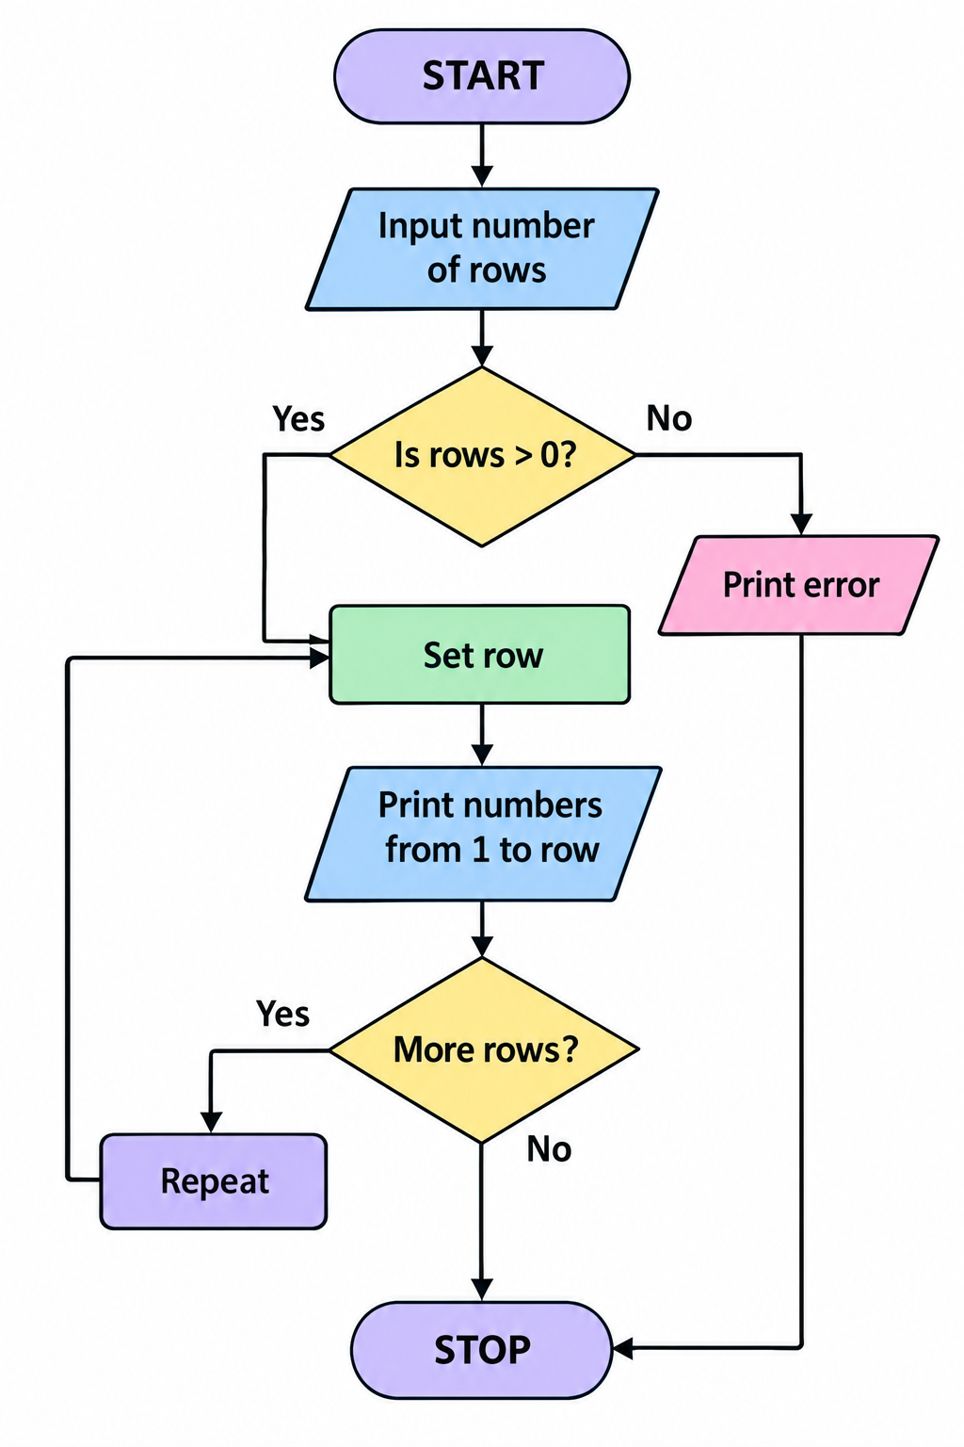

6. Pseudocode
BEGIN
INPUT rows
IF rows <= 0 THEN
PRINT "Enter a positive number"
ELSE
FOR i FROM 1 TO rows
FOR j FROM 1 TO i
PRINT j
END FOR
MOVE TO NEXT LINE
END FOR
END IF
END

7. Python Source Code
print("NUMERIC PATTERN GENERATOR")
rows = int(input("Enter number of rows: "))
if rows <= 0:
print("Please enter a positive number.")
else:
for i in range(1, rows + 1):
for j in range(1, i + 1):
print(j, end=" ")
print()

8. Test Cases
Test Case | Input | Expected Output
1 | 3 | Three rows of numbers
2 | 5 | Five rows of numbers
3 | 1 | 1

9.Screenshots
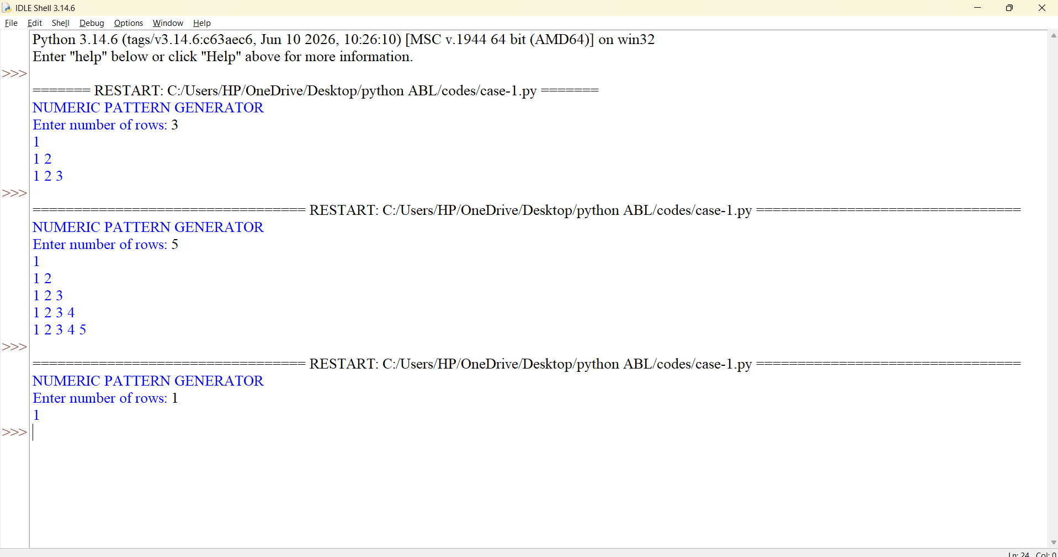

10. Conclusion
The Numeric Pattern Generator demonstrates how nested loops can be used to create numeric patterns. It helps develop an understanding of iteration, user input, and conditional statements in Python.

CASE STUDY 13: ATM TRANSACTION SEQUENCE SIMULATION
1. Problem Statement
Develop a Python program that simulates basic ATM transactions. The program should allow a user to check their balance, deposit money, and withdraw money. It should update the balance after every successful transaction and prevent withdrawals that exceed the available balance.
2. Objectives
- To simulate basic ATM operations.
- To understand conditional statements and loops.
- To perform calculations involving money.
- To validate transactions.
- To update account balances correctly.
3. Assumptions
- The initial account balance is ₹5,000.
- The user can check their balance, deposit money, or withdraw money.
- Deposit and withdrawal amounts must be positive.
- Withdrawals cannot exceed the available balance.
- The program ends when the user selects Exit.
4. Algorithm
- Start the program.
- Initialize the balance to ₹5,000.
- Display the ATM menu.
- Ask the user to select an operation.
- If the selection is 1, display the balance.
- If the selection is 2, accept a deposit amount and update the balance.
- If the selection is 3, accept a withdrawal amount.
- Check whether the withdrawal amount is positive and does not exceed the balance.
- If the selection is 4, terminate the program.
10.Display an error message for invalid menu choices.

5.Flowchart
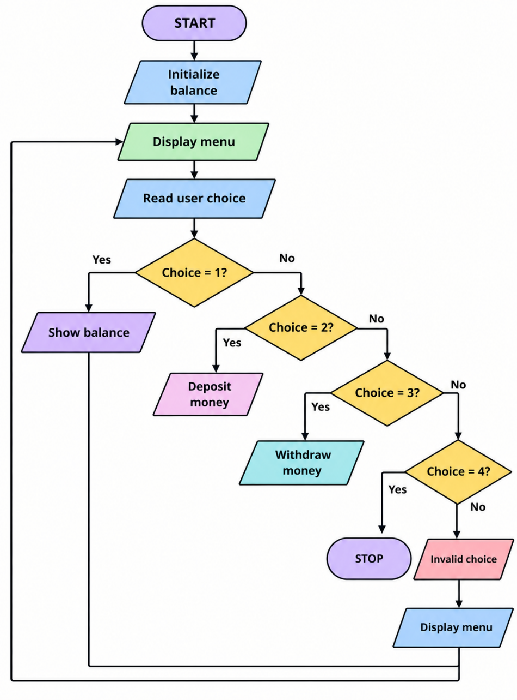

6. Pseudocode
BEGIN
balance = 5000
REPEAT
DISPLAY menu
INPUT choice
IF choice = 1 THEN
DISPLAY balance
ELSE IF choice = 2 THEN
INPUT amount
IF amount > 0 THEN
balance = balance + amount
ELSE
DISPLAY invalid amount
END IF
ELSE IF choice = 3 THEN
INPUT amount
IF amount <= 0 THEN
DISPLAY invalid amount
ELSE IF amount <= balance THEN
balance = balance - amount
ELSE
DISPLAY insufficient balance
END IF

ELSE IF choice = 4 THEN
EXIT LOOP

ELSE
DISPLAY invalid choice
END IF

UNTIL choice = 4
END

7. Python Source Code
print("ATM TRANSACTION SYSTEM")
balance = 5000
while True:
print("\n1. Check Balance")
print("2. Deposit")
print("3. Withdraw")
print("4. Exit")
choice = input("Enter your choice: ")
if choice == "1":
print("Available balance: Rs.", balance)
elif choice == "2":
amount = float(input("Enter deposit amount: "))
if amount > 0:
balance += amount
print("Deposit successful.")
print("Balance:", balance)
else:
print("Enter a positive amount.")
elif choice == "3":
amount = float(input("Enter withdrawal amount: "))
if amount <= 0:
print("Enter a positive amount.")
elif amount <= balance:
balance -= amount
print("Withdrawal successful.")
print("Balance:", balance)
else:
print("Insufficient balance.")
elif choice == "4":
print("Thank you for using ATM.")
break
else:
print("Invalid choice.")

8. Test Cases
Test Case | Operation | Input | Expected Result
1 | Check balance | 1 | Balance ₹5,000
2 | Deposit | ₹1,000 | Balance ₹6,000
3 | Withdraw | ₹500 | Balance ₹4,500 if starting from ₹5,000
4 | Withdraw | ₹6,000 | insufficient balance
5 | Exit | 4 | Program terminates

9.Screenshots

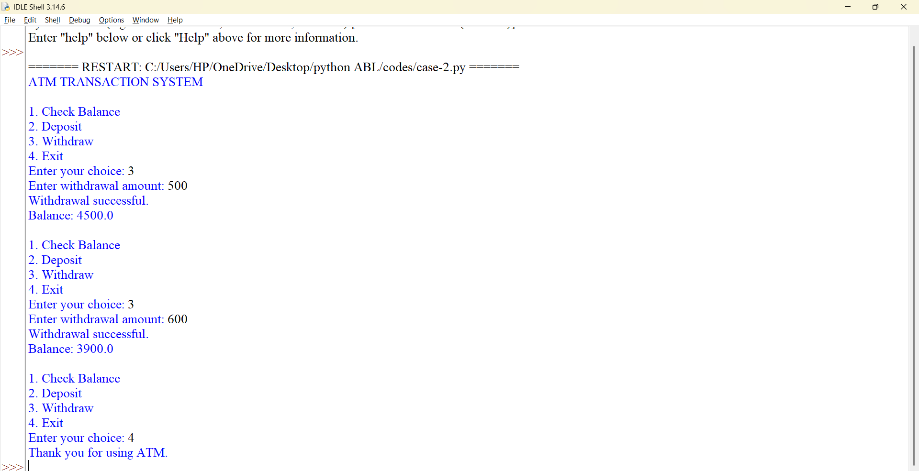

10. Conclusion
The ATM Transaction Simulation demonstrates how Python can be used to model basic banking operations. It applies loops, conditional statements, arithmetic operations, and input validation to process transactions.

CASE STUDY 12: ATTENDANCE RECOVERY COMPUTATION

1. Problem Statement
Develop a Python program to calculate a student's attendance percentage and determine the number of additional classes required to reach a minimum attendance percentage of 75%, assuming the student attends every future class.
2. Objectives
- To calculate attendance percentages.
- To apply mathematical formulas in Python.
- To use conditional statements.
- To determine the number of classes required to reach a target attendance percentage.
3. Assumptions
- Total classes conducted must be positive.
- Attended classes cannot exceed total classes.
- The minimum required attendance is 75%.
- The student attends all future classes.
- The number of required classes is rounded up to the next whole number.
4. Algorithm
- Start the program.
- Input the total number of classes conducted.
- Input the number of classes attended.
- Validate the inputs.
- Calculate attendance percentage.
- If attendance is at least 75%, display that the requirement is satisfied.
- Otherwise, calculate the number of additional classes required.
- Display the result.
- Stop.

5.Flowchart
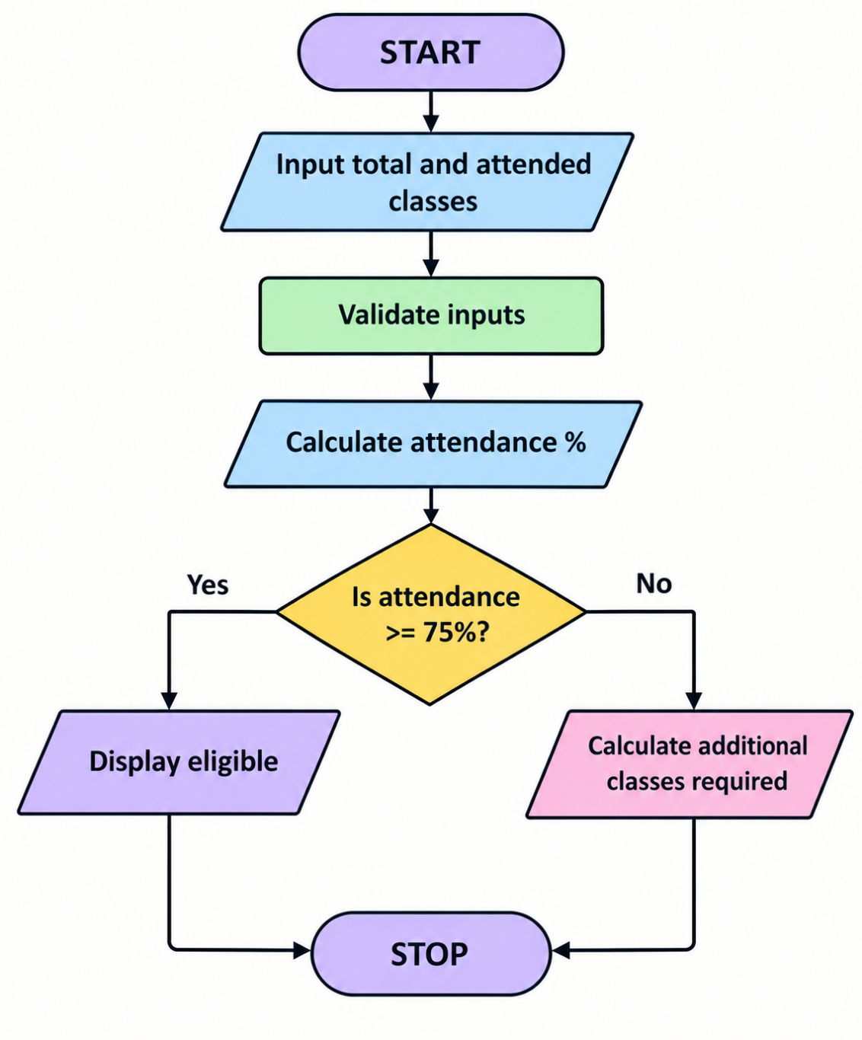

6. Pseudocode
BEGIN
INPUT total
INPUT attended
IF total <= 0 OR attended < 0 OR attended > total THEN
PRINT "Invalid input"
ELSE
percentage = attended / total * 100
PRINT percentage
IF percentage >= 75 THEN
PRINT "Attendance requirement satisfied"
ELSE
required = CEILING(
(0.75 * total - attended) / 0.2)
PRINT required
END IF
END IF
END

7. Python Source Code
import math
print("ATTENDANCE RECOVERY CALCULATOR")
total = int(input("Enter total classes conducted: "))
attended = int(input("Enter classes attended: "))

if total <= 0 or attended < 0 or attended > total:
print("Invalid attendance details.")
else:
percentage = attended / total * 100
print("Attendance percentage:",
round(percentage, 2), "%")
if percentage >= 75:
print("Attendance requirement satisfied.")
else:
required = math.ceil(
(0.75 * total - attended) / 0.25)
print("Additional classes required:", required)

8. Test Cases
Test Case | Total Classes | Attended Classes | Expected Attendance | Additional Classes
1 | 100 | 80 | 80% | 0
2 | 100 | 60 | 60% | 60
3 | 40 | 30 | 75% | 0

9.Screenshots
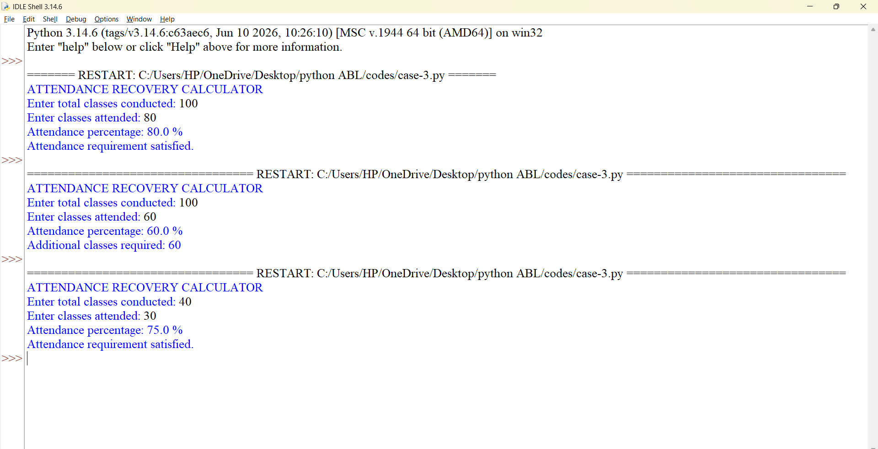

10. Conclusion
The Attendance Recovery Computation program calculates attendance percentages and estimates the number of additional classes required to achieve 75% attendance. It demonstrates the use of mathematical formulas, validation, and conditional statements.

CASE STUDY 17: STUDENT PERFORMANCE TREND ANALYSIS
1. Problem Statement
Develop a Python program to analyze a student's performance across multiple examinations. The program should accept marks from several examinations, calculate the average, identify the highest and lowest marks, and determine whether the student's performance is improving, declining, or remaining stable.
2. Objectives
- To store examination marks in a list.
- To calculate average, maximum, and minimum values.
- To compare examination results.
- To identify performance trends.
- To use loops and conditional statements.
3. Assumptions
- The student has results from three examinations.
- Marks are entered on a scale of 0 to 100.
- The trend is determined by comparing the first and last examination marks.
- An increase indicates improvement, a decrease indicates decline, and equal marks indicate stable performance.
- Intermediate results are not used to determine the final trend.
4. Algorithm
- Start the program.
- Create an empty list to store marks.
- Accept marks for three examinations.
- Validate each mark.
- Calculate the average marks.
- Find the highest and lowest marks.
- Compare the first and last marks.
- Display the performance trend.
- Stop.

5.Flowcharts
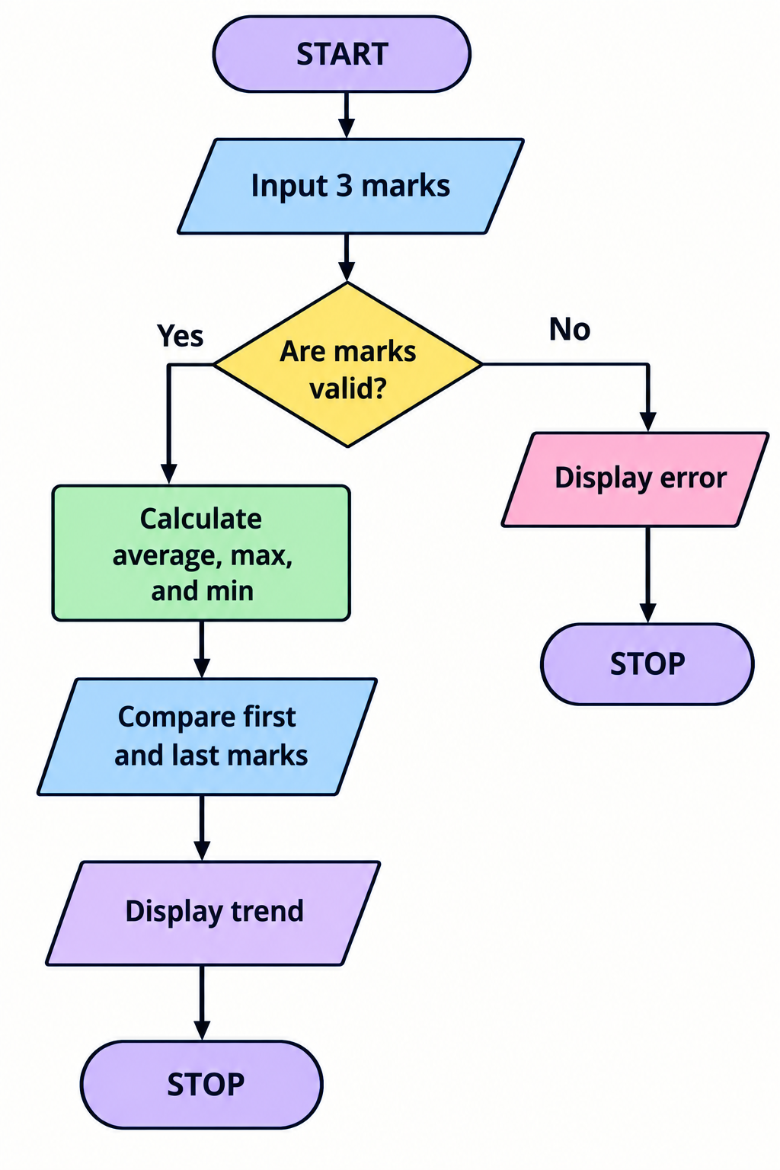

6. Pseudocode
BEGIN
INPUT marks for three examinations
IF any mark < 0 OR any mark > 100 THEN
PRINT "Invalid marks"
ELSE
average = SUM(marks) / 3
highest = MAX(marks)
lowest = MIN(marks)
IF last mark > first mark THEN
trend = "Improving"
ELSE IF last mark < first mark THEN
trend = "Declining"
ELSE
trend = "Stable"
END IF
DISPLAY average, highest, lowest, trend
END IF
END

7. Python Source Code
print("STUDENT PERFORMANCE ANALYSIS")
marks = []
for i in range(1, 4):
mark = float(input(
f"Enter marks for examination {i}: "))
if mark < 0 or mark > 100:
print("Invalid marks. Enter between 0 and 100.")
break
marks.append(mark)
if len(marks) == 3:
average = sum(marks) / 3
print("Average marks:", round(average, 2))
print("Highest marks:", max(marks))
print("Lowest marks:", min(marks))
if marks[2] > marks[0]:
print("Performance is improving.")
elif marks[2] < marks[0]:
print("Performance is declining.")
else:
print("Performance is stable."

8. Test Cases
Test Case | Marks | Expected Trend | Average
1 | 60, 70, 80 | Improving | 70
2 | 90, 80, 70 | Declining | 80
3 | 75, 65, 75 | Stable 71.65

9.Screenshots
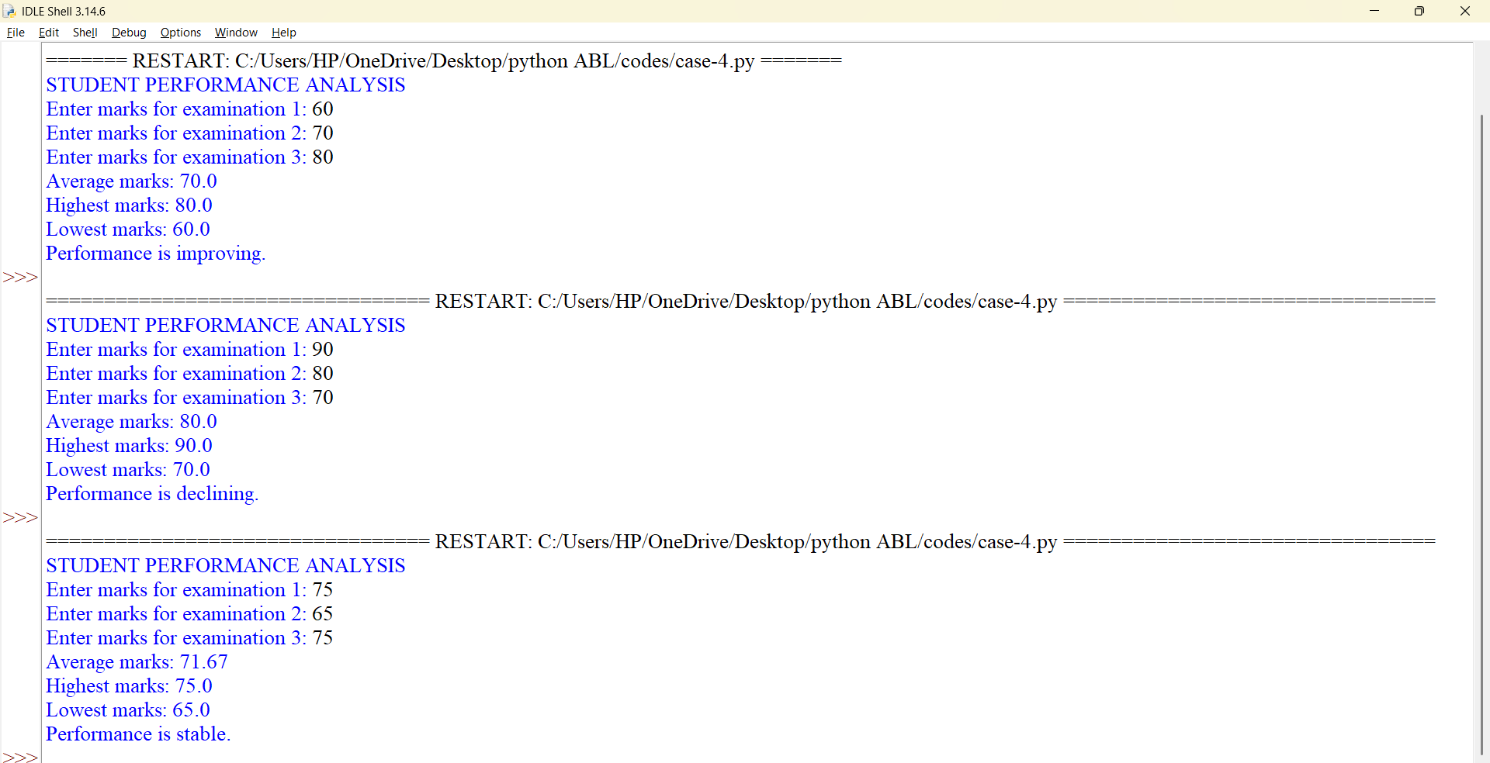

10. Conclusion
The Student Performance Trend Analysis program helps evaluate examination results using basic statistical calculations. It demonstrates lists, loops, built-in functions, and conditional statements.

CASE STUDY 18: FUEL CONSUMPTION AND ROUTE COMPARISON
1. Problem Statement
Develop a Python program to compare the fuel consumption and estimated travel cost of two routes. The program should accept the distance of each route, the vehicle's mileage, and the fuel price. It should calculate the fuel required and cost for each route and identify the more economical option.
2. Objectives
- To calculate fuel consumption.
- To estimate travel expenses.
- To compare two routes.
- To apply arithmetic operations.
- To use conditional statements to select the economical route.
3. Assumptions
- Distances are measured in kilometres.
- Mileage is measured in kilometres per litre.
- Fuel price is measured in rupees per litre.
- Both routes use the same vehicle and fuel price.
- The route with the lower distance has the lower fuel cost.
- Traffic, tolls, and road conditions are not considered.
4. Algorithm
- Start the program.
- Input the distances of Route A and Route B.
- Input the vehicle mileage.
- Input the price of fuel per litre.
- Validate the inputs.
- Calculate fuel consumption for each route.
- Calculate the travel cost for each route.
- Compare the costs.
- Display the more economical route.
- Stop.
5. Flowchart
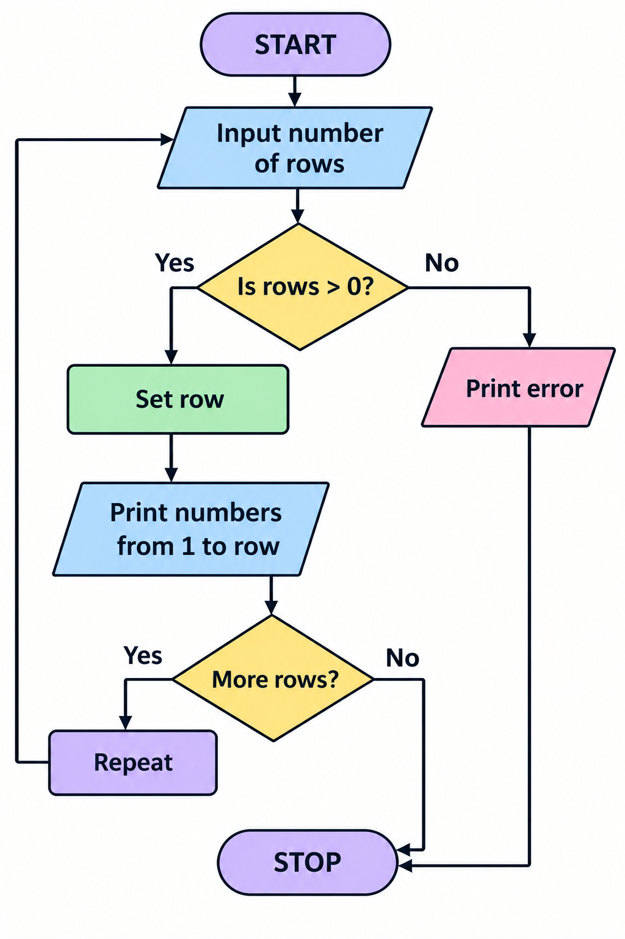

6. Pseudocode
BEGIN
INPUT distanceA
INPUT distanceB
INPUT mileage
INPUT fuelPrice
IF any input is invalid THEN
PRINT "Invalid input"
ELSE
fuelA = distanceA / mileage
fuelB = distanceB / mileage
costA = fuelA * fuelPrice
costB = fuelB * fuelPrice
DISPLAY fuelA, fuelB
DISPLAY costA, costB
IF costA < costB THEN
PRINT "Route A is economical"
ELSE IF costB < costA THEN
PRINT "Route B is economical"
ELSE
PRINT "Both routes cost the same"
END IF
END IF
END

7. Python Source Code
print("FUEL AND ROUTE COMPARISON")
distance_a = float(input("Enter Route A distance: "))
distance_b = float(input("Enter Route B distance: "))
mileage = float(input("Enter vehicle mileage (km/l): "))
fuel_price = float(input("Enter fuel price per litre: "))
if (distance_a <= 0 or distance_b <= 0
or mileage <= 0 or fuel_price <= 0):
print("Please enter positive values.")
else:
fuel_a = distance_a / mileage
fuel_b = distance_b / mileage
cost_a = fuel_a * fuel_price
cost_b = fuel_b * fuel_price
print("Route A fuel required:",
round(fuel_a, 2), "litres")
print("Route A cost: Rs.", round(cost_a, 2))
print("Route B fuel required:",
round(fuel_b, 2), "litres")
print("Route B cost: Rs.", round(cost_b, 2))
if cost_a < cost_b:
print("Route A is more economical.")
elif cost_b < cost_a:
print("Route B is more economical.")
else:
print("Both routes have equal costs.")

8. Test Cases
Test Case | Route A | Route B | Mileage | Fuel Price | Expected Result
1 | 100 km | 150 km | 20 km/l | ₹100/l | Route A
2 | 200 km | 100 km | 25 km/l | ₹100/l | Route B
3 | 100 km | 100 km | 20 km/l | ₹100/l | Equal costs

9.Screenshots
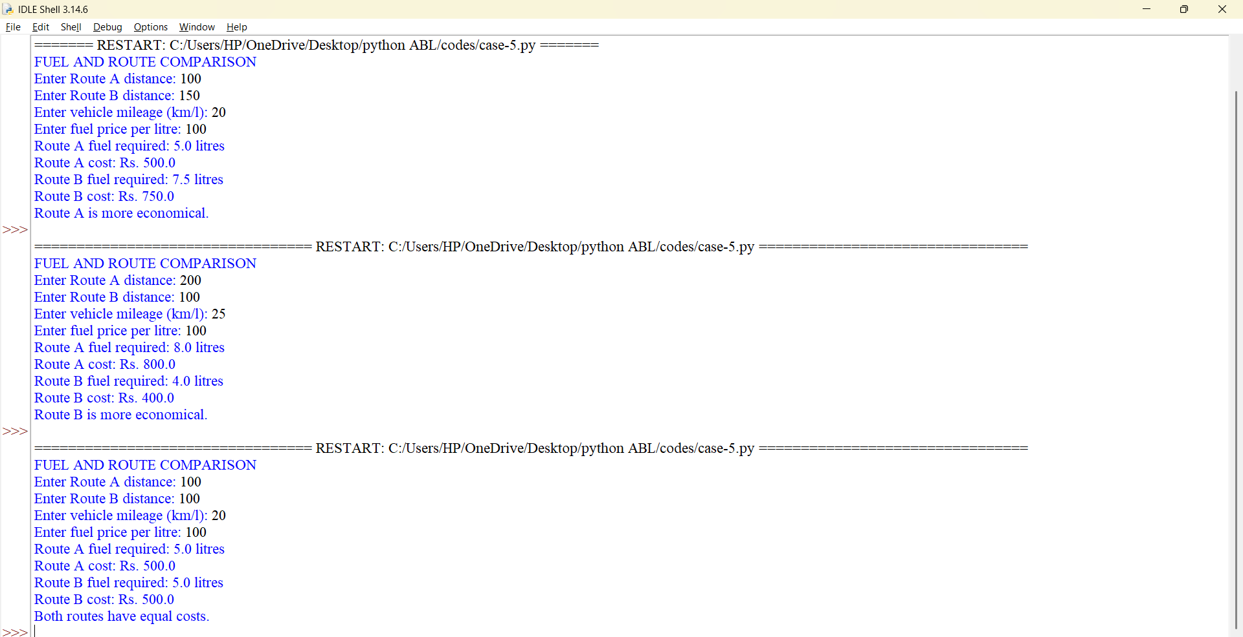

10. Conclusion
The Fuel Consumption and Route Comparison program calculates estimated fuel requirements and travel costs. It demonstrates how mathematical formulas and conditional statements can help compare travel options.

CASE STUDY 28: REPEATED TRANSACTION DETECTION
1. Problem Statement
Develop a Python program to identify repeated transaction IDs in a list of transaction records. The program should accept multiple transaction IDs, identify duplicates, and display the IDs that appear more than once.
2. Objectives
- To identify duplicate transaction records.
- To understand lists and sets in Python.
- To count the occurrences of transaction IDs.
- To demonstrate a basic method of identifying repeated records.
3. Assumptions
- Transaction IDs are entered as strings.
- IDs are compared exactly as entered.
- Two or more occurrences of an ID indicate a repeated transaction.
- The program identifies duplicate IDs but does not determine whether the transactions are fraudulent.
4. Algorithm
- Start the program.
- Input the number of transaction records.
- Accept the transaction IDs.
- Create an empty list for duplicate IDs.
- Check the number of occurrences of each transaction ID.
- If an ID occurs more than once, add it to the duplicate list if not already present.
- Display the repeated transaction IDs.
- If no duplicates exist, display an appropriate message.
- Stop.

5. Flowchart
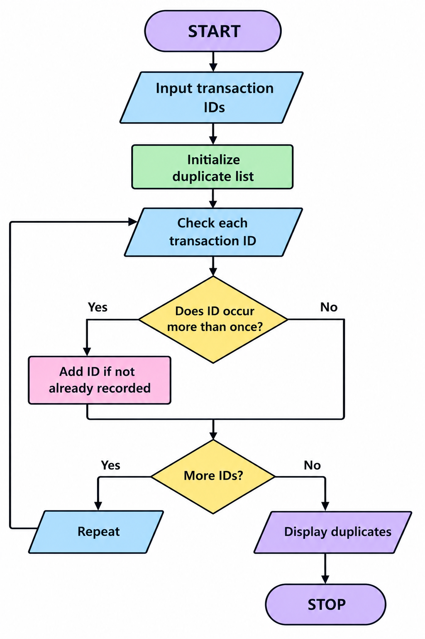

6. Pseudo Code
BEGIN
INPUT number of transactions
INPUT transaction IDs

duplicates = empty list

FOR each ID in transactions
IF count(ID) > 1 AND ID not in duplicates THEN
ADD ID to duplicates
END IF
END FOR

IF duplicates is empty THEN
PRINT "No repeated transactions"
ELSE
PRINT duplicates
END IF
END

7. Python Source Code
print("REPEATED TRANSACTION DETECTOR")
n = int(input("Enter number of transactions: "))
if n <= 0:
print("Enter a positive number.")
else:
transactions = []
for i in range(n):
transaction_id = input(
f"Enter transaction ID {i + 1}: " )
transactions.append(transaction_id)

duplicates = []

for transaction_id in transactions:
if (transactions.count(transaction_id) > 1
and transaction_id not in duplicates):
duplicates.append(transaction_id)

if duplicates:
print("Repeated transaction IDs:")
for transaction_id in duplicates:
print(transaction_id)
else:
print("No repeated transactions found.")

8.Test Cases
Test Case | Transaction IDs | Expected Output
1 | T101, T102, T101 | T101
2 | A1, A2, A3 | No duplicates
3 | X1, X1, X1 | X1 displayed once
4 | B1, B2, B1, B2 | B1 and B2
5 | One transaction: P1 | No duplicates

9.Screenshots
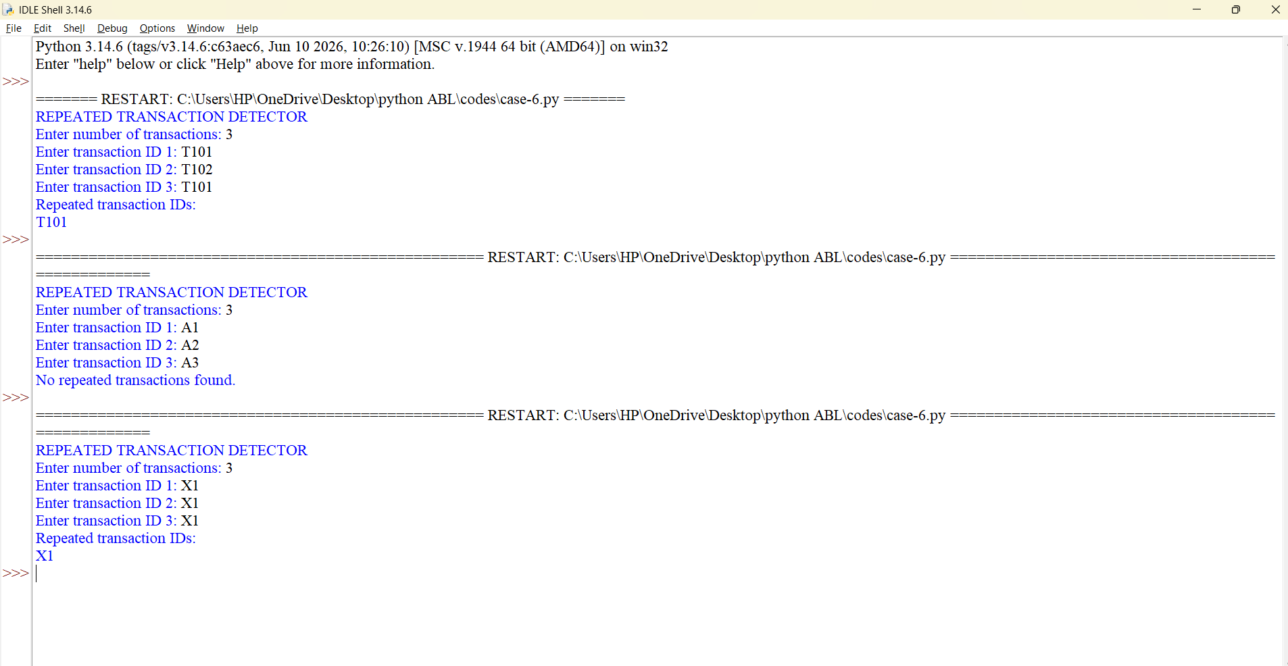

10. Conclusion
The Repeated Transaction Detection program identifies duplicate transaction IDs using lists and conditional statements. It demonstrates a simple approach to detecting repeated records in a transaction dataset

CASE STUDY 29: PASSWORD POLICY VALIDATION ENGINE
1. Problem Statement
Develop a Python program to validate a password according to a set of predefined rules. The password must have a minimum length and contain uppercase letters, lowercase letters, digits, and special characters.
2. Objectives
- To validate passwords using Python.
- To understand string operations.
- To use conditional statements.
- To identify uppercase letters, lowercase letters, digits, and special characters.
- To encourage the use of stronger passwords.
3. Assumptions
A password is considered valid when it satisfies all the following conditions:
- It contains at least 8 characters.
- It contains at least one uppercase letter.
- It contains at least one lowercase letter.
- It contains at least one digit.
- It contains at least one special character.
- Password strength is determined only by these rules.
4. Algorithm
- Start the program.
- Accept a password from the user.
- Check whether its length is at least 8.
- Check whether it contains an uppercase letter.
- Check whether it contains a lowercase letter.
- Check whether it contains a digit.
- Check whether it contains a special character.
- If all conditions are satisfied, display that the password is valid.
- Otherwise, display the requirements that are not satisfied.
- Stop.

5. Flowchart
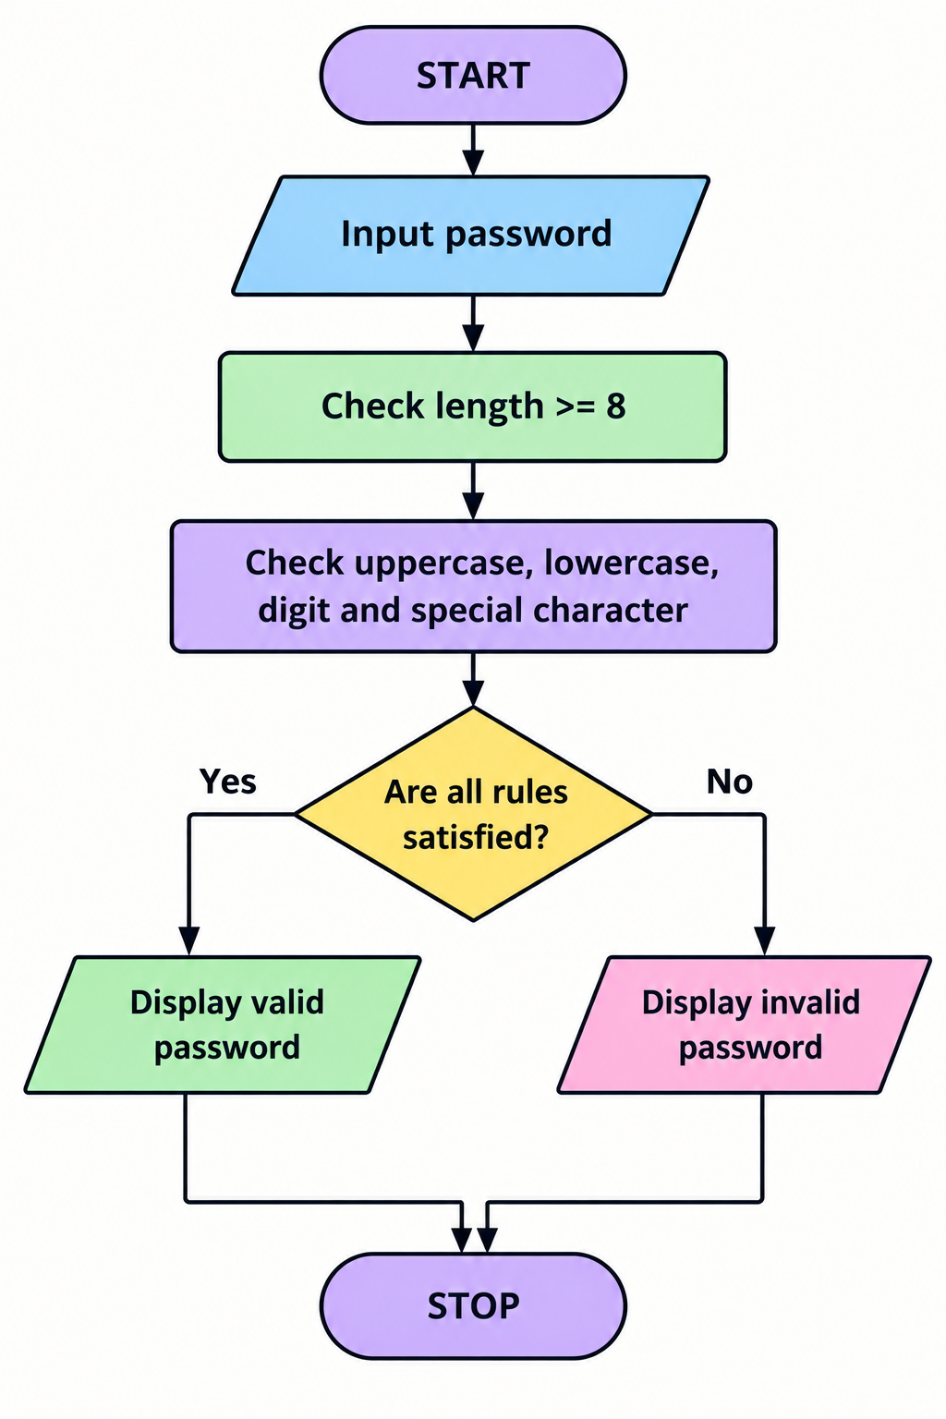
6. Pseudocode
BEGIN
INPUT password
valid_length = length(password) >= 8
uppercase = contains uppercase letter
lowercase = contains lowercase letter
digit = contains digit
special = contains special character
IF all conditions are TRUE THEN
PRINT "Valid password"
ELSE
PRINT "Invalid password"
DISPLAY unmet conditions
END IF
END

7. Python Source Code
print("PASSWORD VALIDATION ENGINE")
password = input("Enter your password: ")
has_upper = any(ch.isupper() for ch in password)
has_lower = any(ch.islower() for ch in password)
has_digit = any(ch.isdigit() for ch in password)

has_special = any(
not ch.isalnum() and not ch.isspace()
for ch in password
)
errors = []
if len(password) < 8:
errors.append("At least 8 characters required.")
if not has_upper:
errors.append("Include an uppercase letter.")
if not has_lower:
errors.append("Include a lowercase letter.")
if not has_digit:
errors.append("Include a digit.")
if not has_special:
errors.append("Include a special character.")
if errors:
print("Password is invalid.")
for error in errors:
print("-", error)
else:
print("Password satisfies all rules.")

8. Test Cases
Test Case | Password | Expected Result
1 | Hello@123 | Valid
2 | hello123 | Invalid
3 | HELLO@123 | Invalid

9.screenshots:
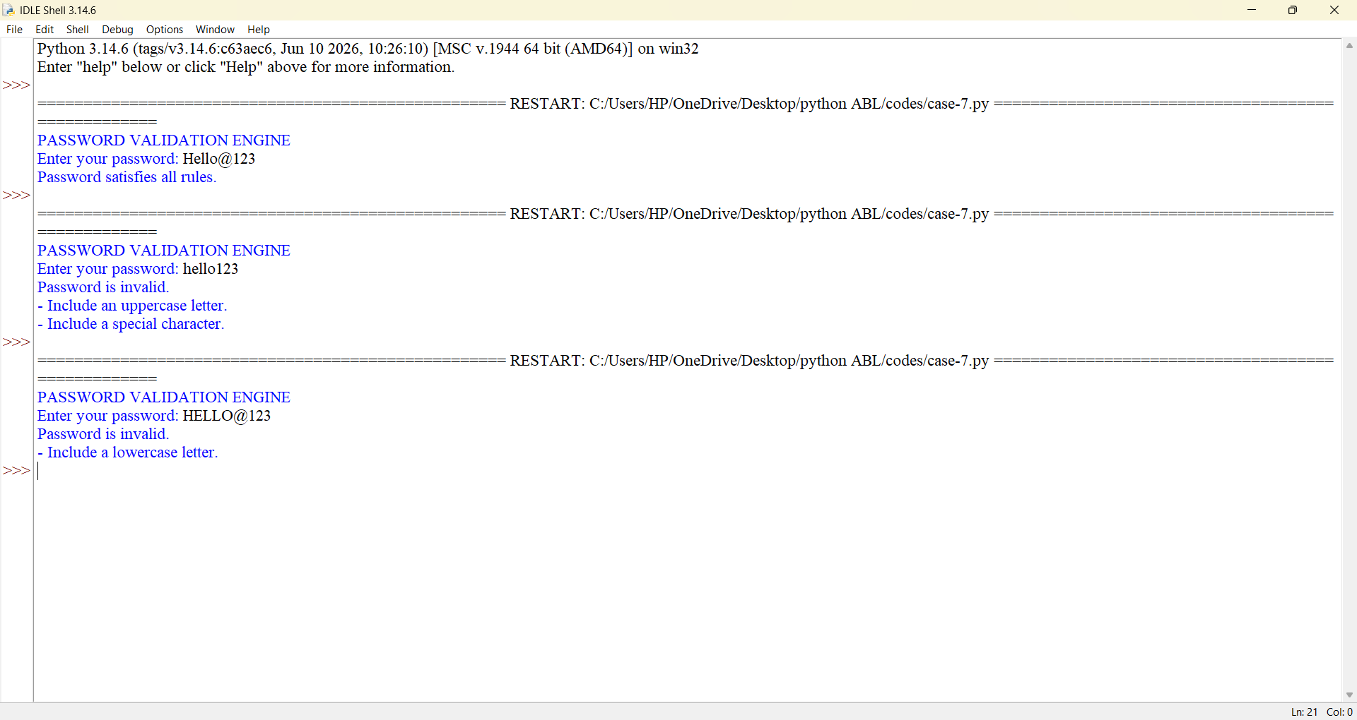

10. Conclusion
The Password Policy Validation Engine checks whether a password satisfies predefined complexity requirements. It demonstrates string methods, iteration, Boolean conditions, and input validation. It is an educational example and does not replace a complete password-security system.

CASE STUDY 31: STRING-BASED EXAMINATION ANSWER EVALUATION
1. Problem Statement
Develop a Python program to evaluate a student's examination answers by comparing them with an answer key. The program should calculate the number of correct answers, incorrect answers, and the final score.
2. Objectives
- To compare strings in Python.
- To evaluate examination answers automatically.
- To calculate the final score.
- To use lists and loops.
- To reduce manual evaluation effort.
3. Assumptions
- The examination contains five multiple-choice questions.
- Each question has one correct answer.
- Each correct answer receives one mark.
- Incorrect answers receive zero marks.
- Answers are single letters such as A, B, C, or D.
- Uppercase and lowercase answers are treated equally.
- Negative marking is not applied.
4. Algorithm
- Start the program.
- Define the correct answer key.
- Accept the student's answers.
- Convert answers to uppercase.
- Compare each answer with the corresponding answer key.
- Count the correct and incorrect answers.
- Calculate the score.
- Display the result.
- Stop.
5. Flowchart
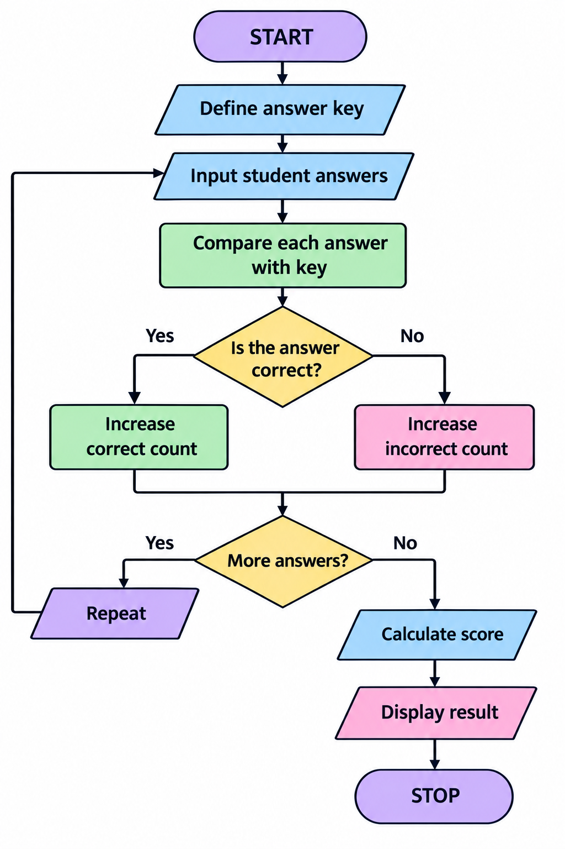
6. Pseudocode
BEGIN
answer_key = [A, B, C, D, A]
correct = 0
incorrect = 0
INPUT five student answers
FOR each answer
CONVERT answer to uppercase
IF answer matches answer key THEN
correct = correct + 1
ELSE
incorrect = incorrect + 1
END IF
END FOR
score = correct
DISPLAY correct, incorrect, score
END
7. Python Source Code
print("EXAMINATION ANSWER EVALUATION")
answer_key = ["A", "B", "C", "D", "A"]
student_answers = []
for i in range(5):
answer = input(
f"Enter answer for question {i + 1}: "
).strip().upper()
if answer not in ["A", "B", "C", "D"]:
print("Invalid answer. Use A, B, C, or D.")
break
student_answers.append(answer)
if len(student_answers) == 5:
correct = 0
for i in range(5):
if student_answers[i] == answer_key[i]:
correct += 1
incorrect = 5 - correct
score = correct
print("Correct answers:", correct)
print("Incorrect answers:", incorrect)
print("Final score:", score, "/ 5")

8. Test Cases
Test Case | Student Answers | Correct | Incorrect | Score
1 | A, B, C, D, A | 5 | 0 | 5
2 | A, A, C, B, A | 3 | 2 | 3
3 | B, A, D, C, B | 0 | 5
9.Screenshots
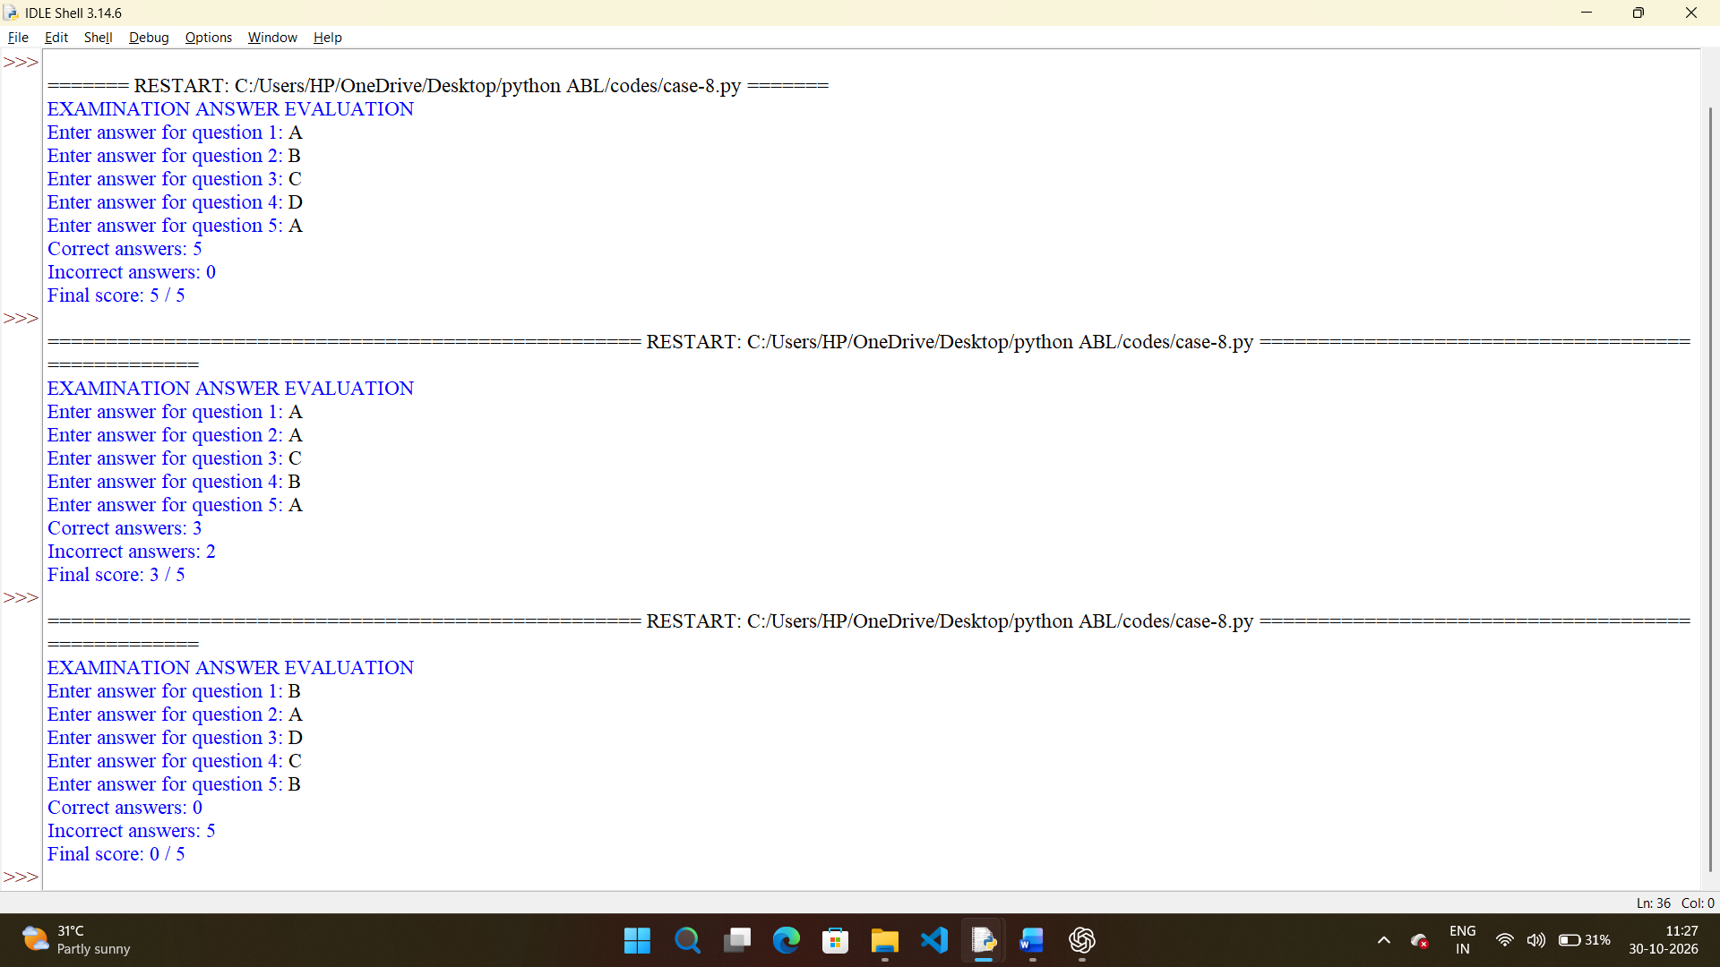

10. Conclusion
The String-Based Examination Answer Evaluation program automates the evaluation of multiple-choice answers. It demonstrates string comparison, lists, loops, and counting operations in Python.

CASE STUDY 42: STUDENT MARKS MATRIX ANALYSIS
1. Problem Statement
Develop a Python program to analyze student marks stored in a matrix. Each row represents a student, and each column represents a subject. The program should calculate each student's total and average marks and identify the student with the highest total.
2. Objectives
- To understand two-dimensional lists in Python.
- To store marks in matrix form.
- To calculate student totals and averages.
- To identify the highest-performing student.
- To use nested loops and built-in functions.
3. Assumptions
- The program evaluates three students.
- Each student has marks in three subjects.
- Marks range from 0 to 100.
- The matrix contains three rows and three columns.
- Student names are entered separately.
- The student with the highest total is considered the top performer.
4. Algorithm
- Start the program.
- Create an empty list for student names.
- Create an empty matrix for marks.
- Accept the names of three students.
- Accept three subject marks for each student.
- Validate the marks.
- Calculate each student's total and average.
- Identify the student with the highest total.
- Display the results.
- Stop.
5. Flowchart
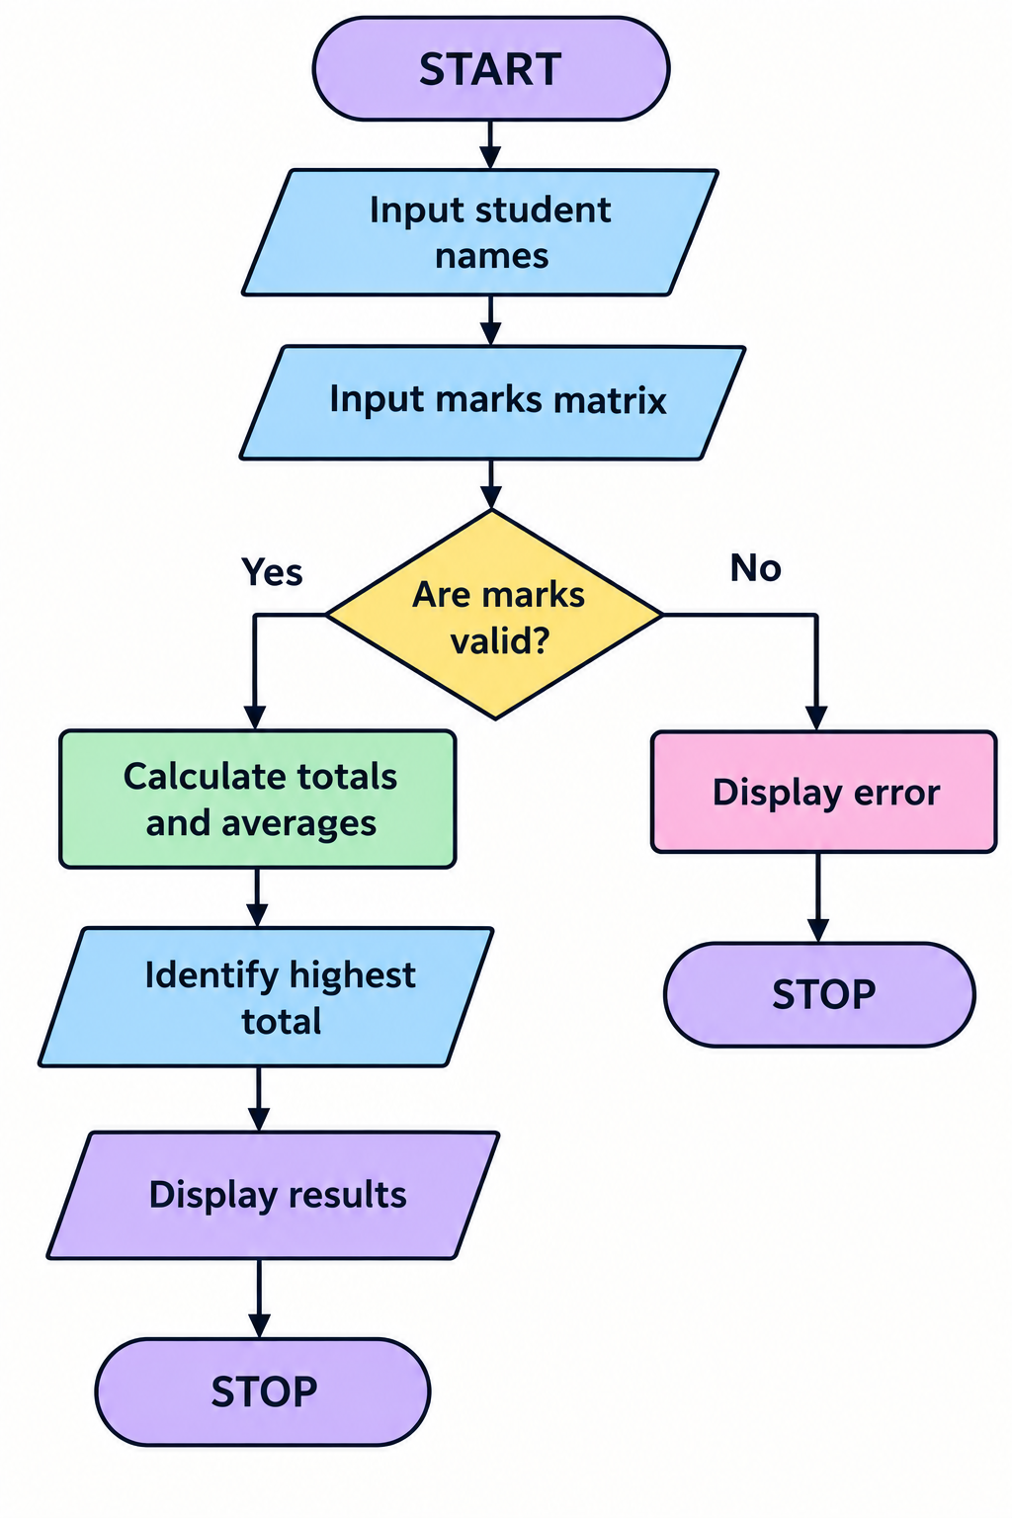
6. Pseudocode
BEGIN
students = empty list
marks = empty matrix
FOR each of 3 students
INPUT student name
INPUT marks for 3 subject
IF any mark < 0 OR any mark > 100 THEN
PRINT "Invalid marks"
STOP
END IF
ADD name to students
ADD marks to matrix
END FOR
FOR each student
total = SUM(student marks)
average = total / 3
DISPLAY total and average
END FOR
FIND student with highest total
DISPLAY top student
END

7. Python Source Code
print("STUDENT MARKS MATRIX ANALYSIS")
students = []
marks = []
for i in range(3):
name = input(f"Enter student {i + 1} name: ")
students.append(name)
row = []
for j in range(3):
mark = float(input(
f"Enter subject {j + 1} marks for {name}: "
))
if mark < 0 or mark > 100:
print("Invalid marks.")
break
row.append(mark)
if len(row) != 3:
break
marks.append(row)
if len(marks) == 3:
totals = []
averages = []

for row in marks:
total = sum(row)
average = total / 3
totals.append(total)
averages.append(average)
for i in range(3):
print("\nStudent:", students[i])
print("Total:", totals[i])
print("Average:", round(averages[i], 2))
top_index = totals.index(max(totals))
print("\nTop performer:", students[top_index])
print("Highest total:", totals[top_index])

8. Test Cases
Test Case | Student | Subject 1 | Subject 2 | Subject 3 | Total
1 | Ravi | 80 | 90 | 70 | 240
2 | Sita | 85 | 95 | 90 | 270
3 | Aman | 70 | 75 | 80 | 225

9.screenshots
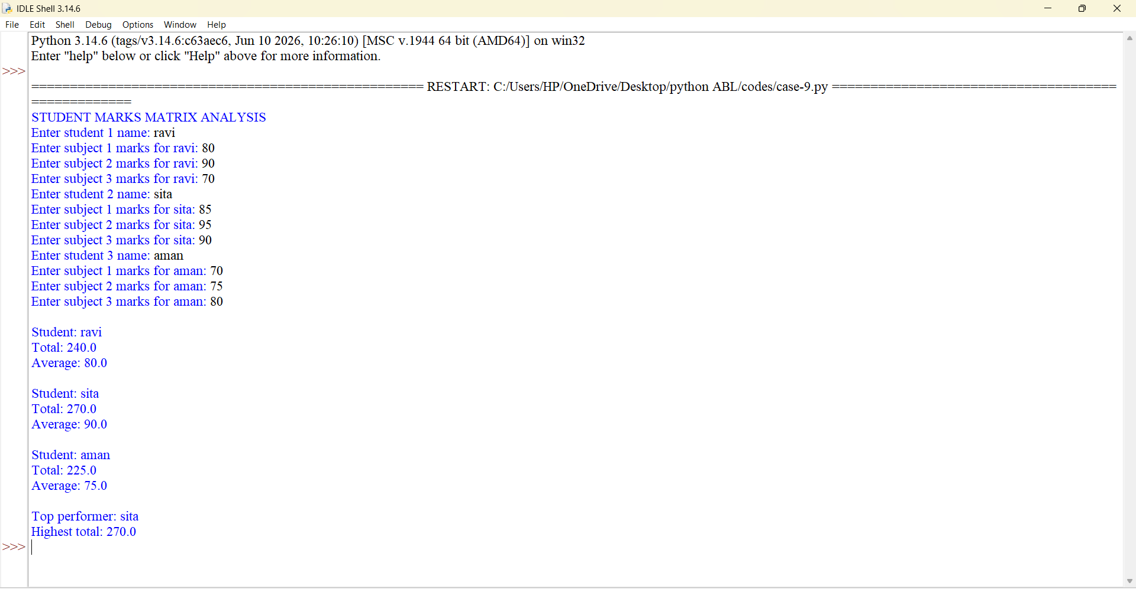

10. Conclusion
The Student Marks Matrix Analysis program stores and analyzes student marks using a two-dimensional list. It demonstrates matrix-style data storage, nested loops, arithmetic calculations, and maximum-value identification.

CASE STUDY 53: FOOD WASTE MONITORING SYSTEM
1. Problem Statement
Develop a Python program to monitor food prepared, food consumed, and food wasted. The program should calculate the amount of food wasted and the percentage of food waste. It should also display a message based on the percentage of waste.
2. Objectives
- To monitor food waste.
- To calculate the quantity of wasted food.
- To calculate the percentage of waste.
- To encourage responsible food management.
- To apply arithmetic operations and conditional statements.
3. Assumptions
- Food quantities are measured in kilograms.
- Total food prepared must be greater than zero.
- Food consumed cannot exceed food prepared.
- Food wasted equals food prepared minus food consumed.
- A waste percentage greater than 20% is considered high for this educational example.
- The threshold is illustrative and is not an official food-waste standard.
4. Algorithm
- Start the program.
- Input the total quantity of food prepared.
- Input the quantity of food consumed.
- Validate the quantities.
- Calculate the wasted food.
- Calculate the waste percentage.
- If waste is greater than 20%, display a high-waste warning.
- Otherwise, display that food waste is within the defined limit.
- Display all calculated values.
- Stop.
5. Flowchart
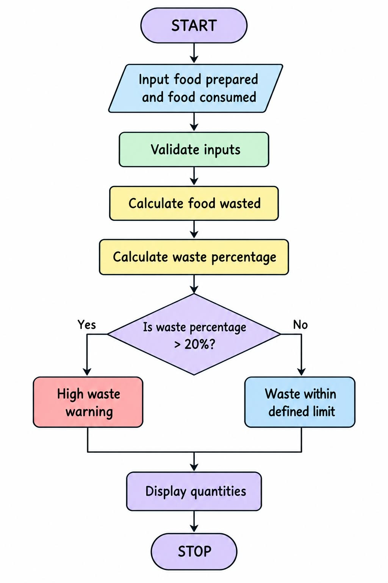
6. Pseudocode
BEGIN
INPUT prepared
INPUT consumed
IF prepared <= 0 OR consumed < 0
OR consumed > prepared THEN
PRINT "Invalid input"
ELSE
wasted = prepared - consumed
percentage = wasted / prepared * 100
DISPLAY wasted
DISPLAY percentage
IF percentage > 20 THEN
PRINT "High food waste"
ELSE
PRINT "Food waste within defined limit"
END IF
END IF
END

7. Python Source Code
print("FOOD WASTE MONITORING SYSTEM")
prepared = float(input(
"Enter food prepared in kg: "
))
consumed = float(input(
"Enter food consumed in kg: "
))
if prepared <= 0 or consumed < 0 or consumed > prepared:
print("Invalid food quantities.")
else:
wasted = prepared - consumed
percentage = wasted / prepared * 100
print("Food prepared:", prepared, "kg")
print("Food consumed:", consumed, "kg")
print("Food wasted:", round(wasted, 2), "kg")
print("Waste percentage:",
round(percentage, 2), "%")
if percentage > 20:
print("Warning: High food waste!")
print("Consider preparing less food.")
else:
print("Food waste is within the defined limit.")
8. Test Cases
Test Case | Food Prepared | Food Consumed | Food Wasted | Waste Percentage | Expected Result
1 | 100 kg | 90 kg | 10 kg | 10% | Within limit
2 | 100 kg | 70 kg | 30 kg | 30% | High waste
3 | 50 kg | 50 kg | 0 kg | 0% | Within limit

9.screenshots
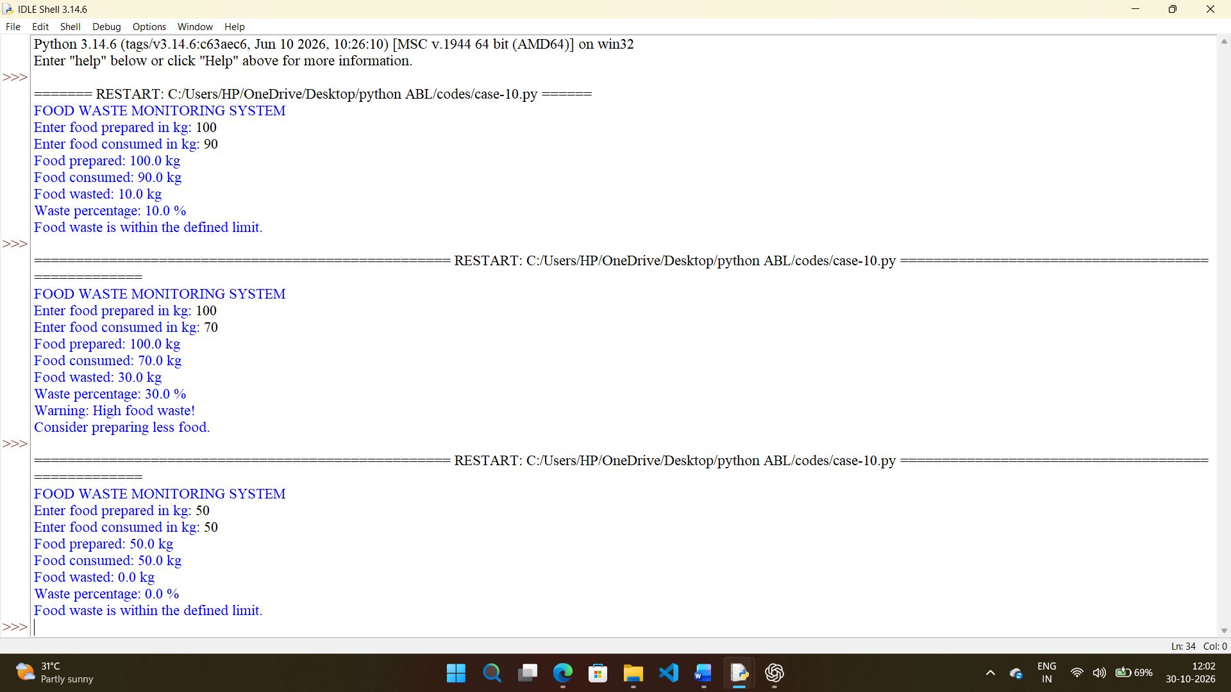

10. Conclusion
The Food Waste Monitoring System calculates the amount and percentage of wasted food. It demonstrates the use of mathematical formulas, conditional statements, and input validation while promoting awareness of food conservation.

